BACK BY POPULAR DEMAND!


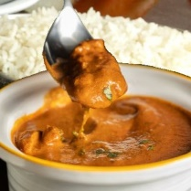
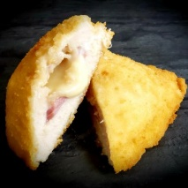
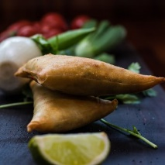
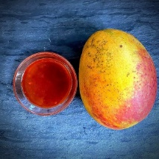
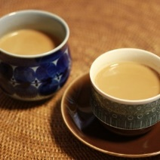
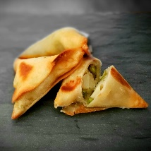

This fall we are bringing back the delicious fundraiser featuring samosa’s, accompanying sauces & chutneys, authentic Indian Chai, butter chicken sauce & premium basmati rice, superior quality chicken cordon blues, and more!

This tasty food is local, hand-made and arrives fully cooked, frozen, and ready for your freezer.
Simply reheat in the oven and serve – they are great for entertaining (when it’s safe to do that again) or as a meal (2-3 samosas with a salad could be lunch ;-). Don’t forget to order an accompanying mango chutney!

Please click HERE to access the BROOKBANK SAMOSA FUNDRAISER

Below are the instructions for accessing the ordering page:

1. Clicking on the unique link provided above will take you to the welcome page. At this point you are in the Brooksbank fundraiser and your order will be attributed to Brooksbank Elementary.

2. Please click the blue "Shop Now" button or "Shop Here" in the menu bar.
- You can surf the site and go shopping later in the session
- If you leave the site and return later, there is a chance that the order won't be automatically attributed to the Brooksbank fundraiser. So, to be safe, it's important that you always use the Brooksbank link to make a purchase.

3. Place you order by filling your cart and proceeding to the checkout.
- At checkout you will see the message re: pickup time and location.
- You will also see this information on your receipt.

4. You have the option to pay by either Interac e-Transfer or credit card.
- If you choose e-transfer, the etransfer will need to be sent to samosafundraiser@gmail.com and the order number should be included in the etransfer message field. A password is not needed for etransfers as the account is set up to automatically deposit the transferred funds.
- For credit card payment they select the "Credit Card Payments" button.

5. Once payment has been sent, “Place Order" and a receipt will be emailed to you.

Orders open now, until September 25th.
Pick Up at BB Parking Lot on October 9th.

